

**Science/Social Studies**

cAlar

This week, we will be reading Story 29, “Two of Everything.” Students will be spelling words that have the ai and ay sounds. Also, they will be reviewing understanding characters and summarizing. Also, they will be reviewing antonyms. In Grammar, they will continue to practice possessive pronouns.

**High-Frequency Words:** eight, near, once, paper, seven, upon, wash, who, woman, your

**Vocabulary Words:** search, contained, startled, odd, leaned, tossed, grateful, village

**Reading Test:** Friday, May 16th

In Science, we will be analyzing habitat photos to make claims about how habitats can affect a plant’s growth and reproduction.



In Social Studies, the students will be investigating how people have made and can make a difference in the world. Also, they will be exploring different ways to make an impact, from social justice to scientific discoveries. Lastly, they will be investigating how art and athletics can impact our world.

Highlands Elementary School

Week of May 12th-16th,2025

This week in Math, we will be practicing approximating(estimating)sums and differences in real-life situations. Also, students will be practicing using a calculator as a tool to calculate sums and differences.

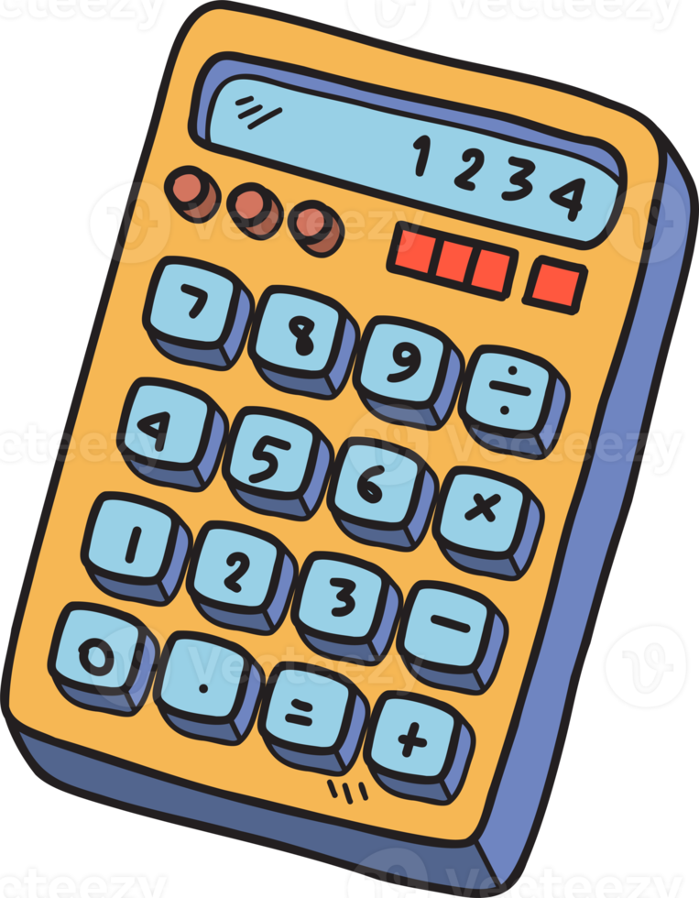

Miss McCurdy’s Classroom Newsletter

# Math

# Language Arts

banner with apples and crayons

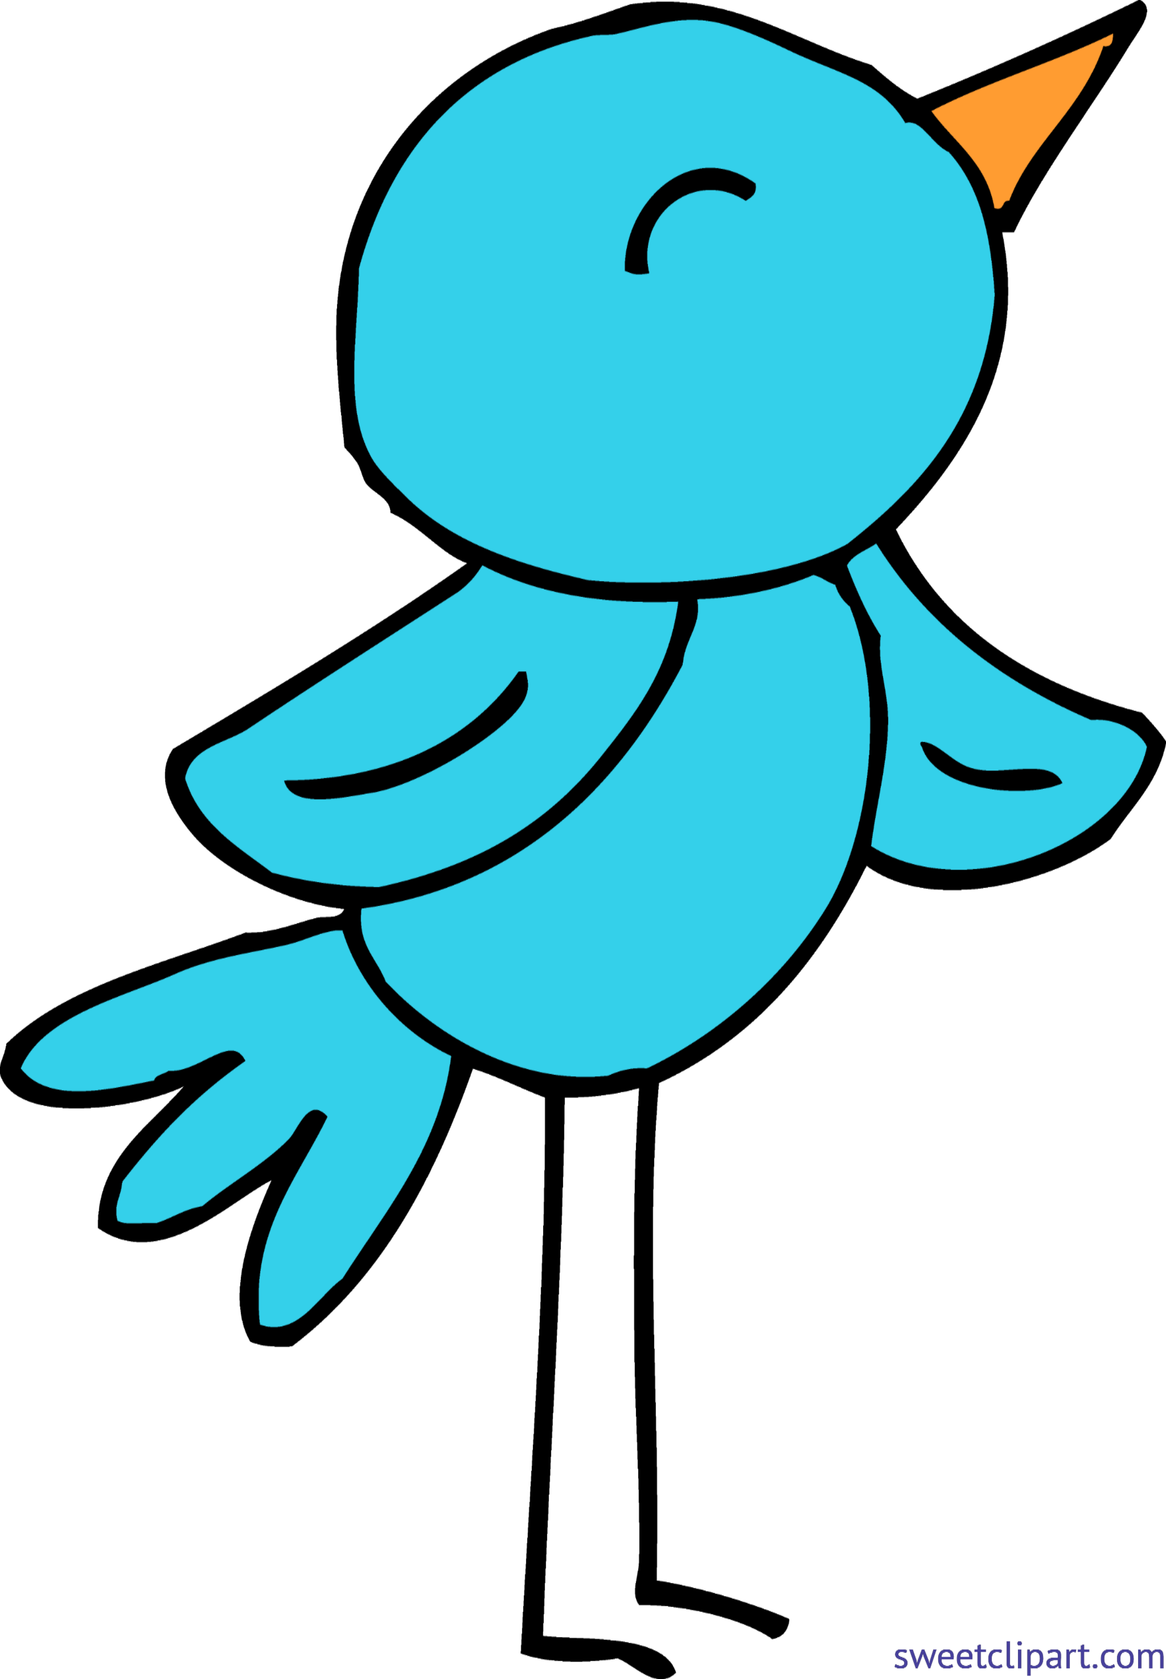

**Wednesday, May 21st**: 4th Grade Spring Band Concert—6:00 P.M.

**Thursday, May 22nd:** Introduction to Fitness Trainer in A.M. & Fitness Trainer Presentation in P.M.; Summer Reading Program from Allegheny Valley Library 2:20 P.M. -2: 40 P.M.

**Friday, May 23rd**: Fitness Trainer RIASEC Party—ALL DAY!

**Monday, May 26th:** MEMORIAL DAY! NO SCHOOL FOR STUDENTS/STAFF

**Wednesday, May 28th:** Fun Fest for Grades 2 & 4

**Friday, May 30th:** Brown and Gold Day!

**Monday, June 2nd:** 2nd Grade Field Trip to Pittsburgh Zoo and Aquarium

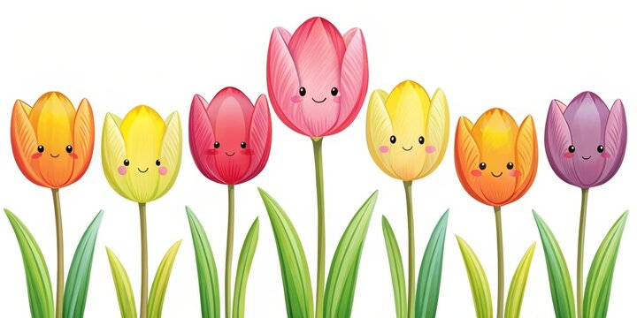

# This Week’s Happenings!

## Upcoming Events

End of the year testing has begun! ***Please make sure you are having your child “charge” their Chromebooks nightly.***



**Parent’s Corner**

**Language Arts:** Review high-frequency and vocabulary words on study guide; Re-read pages 456-465 in Student Reading Book or listen to story on Think Central

**Math:** NONE

**Science:** NONE

**Social Studies:** NONE



Miss McCurdy’s Classroom Newsletter Page 2

# This Week’s Assignments

* In Reading/ELA, the students read a fairy tale which was a “spin -off” of Cinderella. The students talked about the similarities and differences between the two stories.
* In Math, we practiced finding half of numbers and writing addition and subtraction number stories.
* In Science, we continued to work on our Habitat lapbooks.
* In Social Studies, we continued to learn about the government. Also, we worked on Mother’s Day projects for our AMAZING moms!

Monday- Day 6

Regular Schedule

Physical Education *Wear

Tennis Shoes

Tuesday- Day 1

Regular Schedule

Foreign Language Class

Wednesday- **Day 2**

Regular Schedule

Computers

Thursday-

Day 3

Regular Schedule

Library *Bring Library Book Back!

Friday—

Day 4

Regular Schedule

Music

Brown and Gold Day!

## Second Grade Buzz C:\Documents and Settings\Administrator\Local Settings\Temporary Internet Files\Content.IE5\SJHPR24O\MC900353704[1].wmf